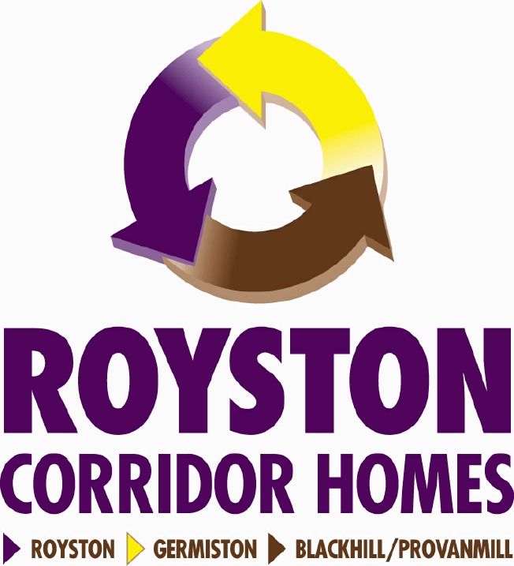

DEMOLITION OF 15 COLL PLACE, GLASGOW
EVACUATION – SATURDAY 14TH MAY 2011
DEMOLITION – SUNDAY 15TH MAY 2011
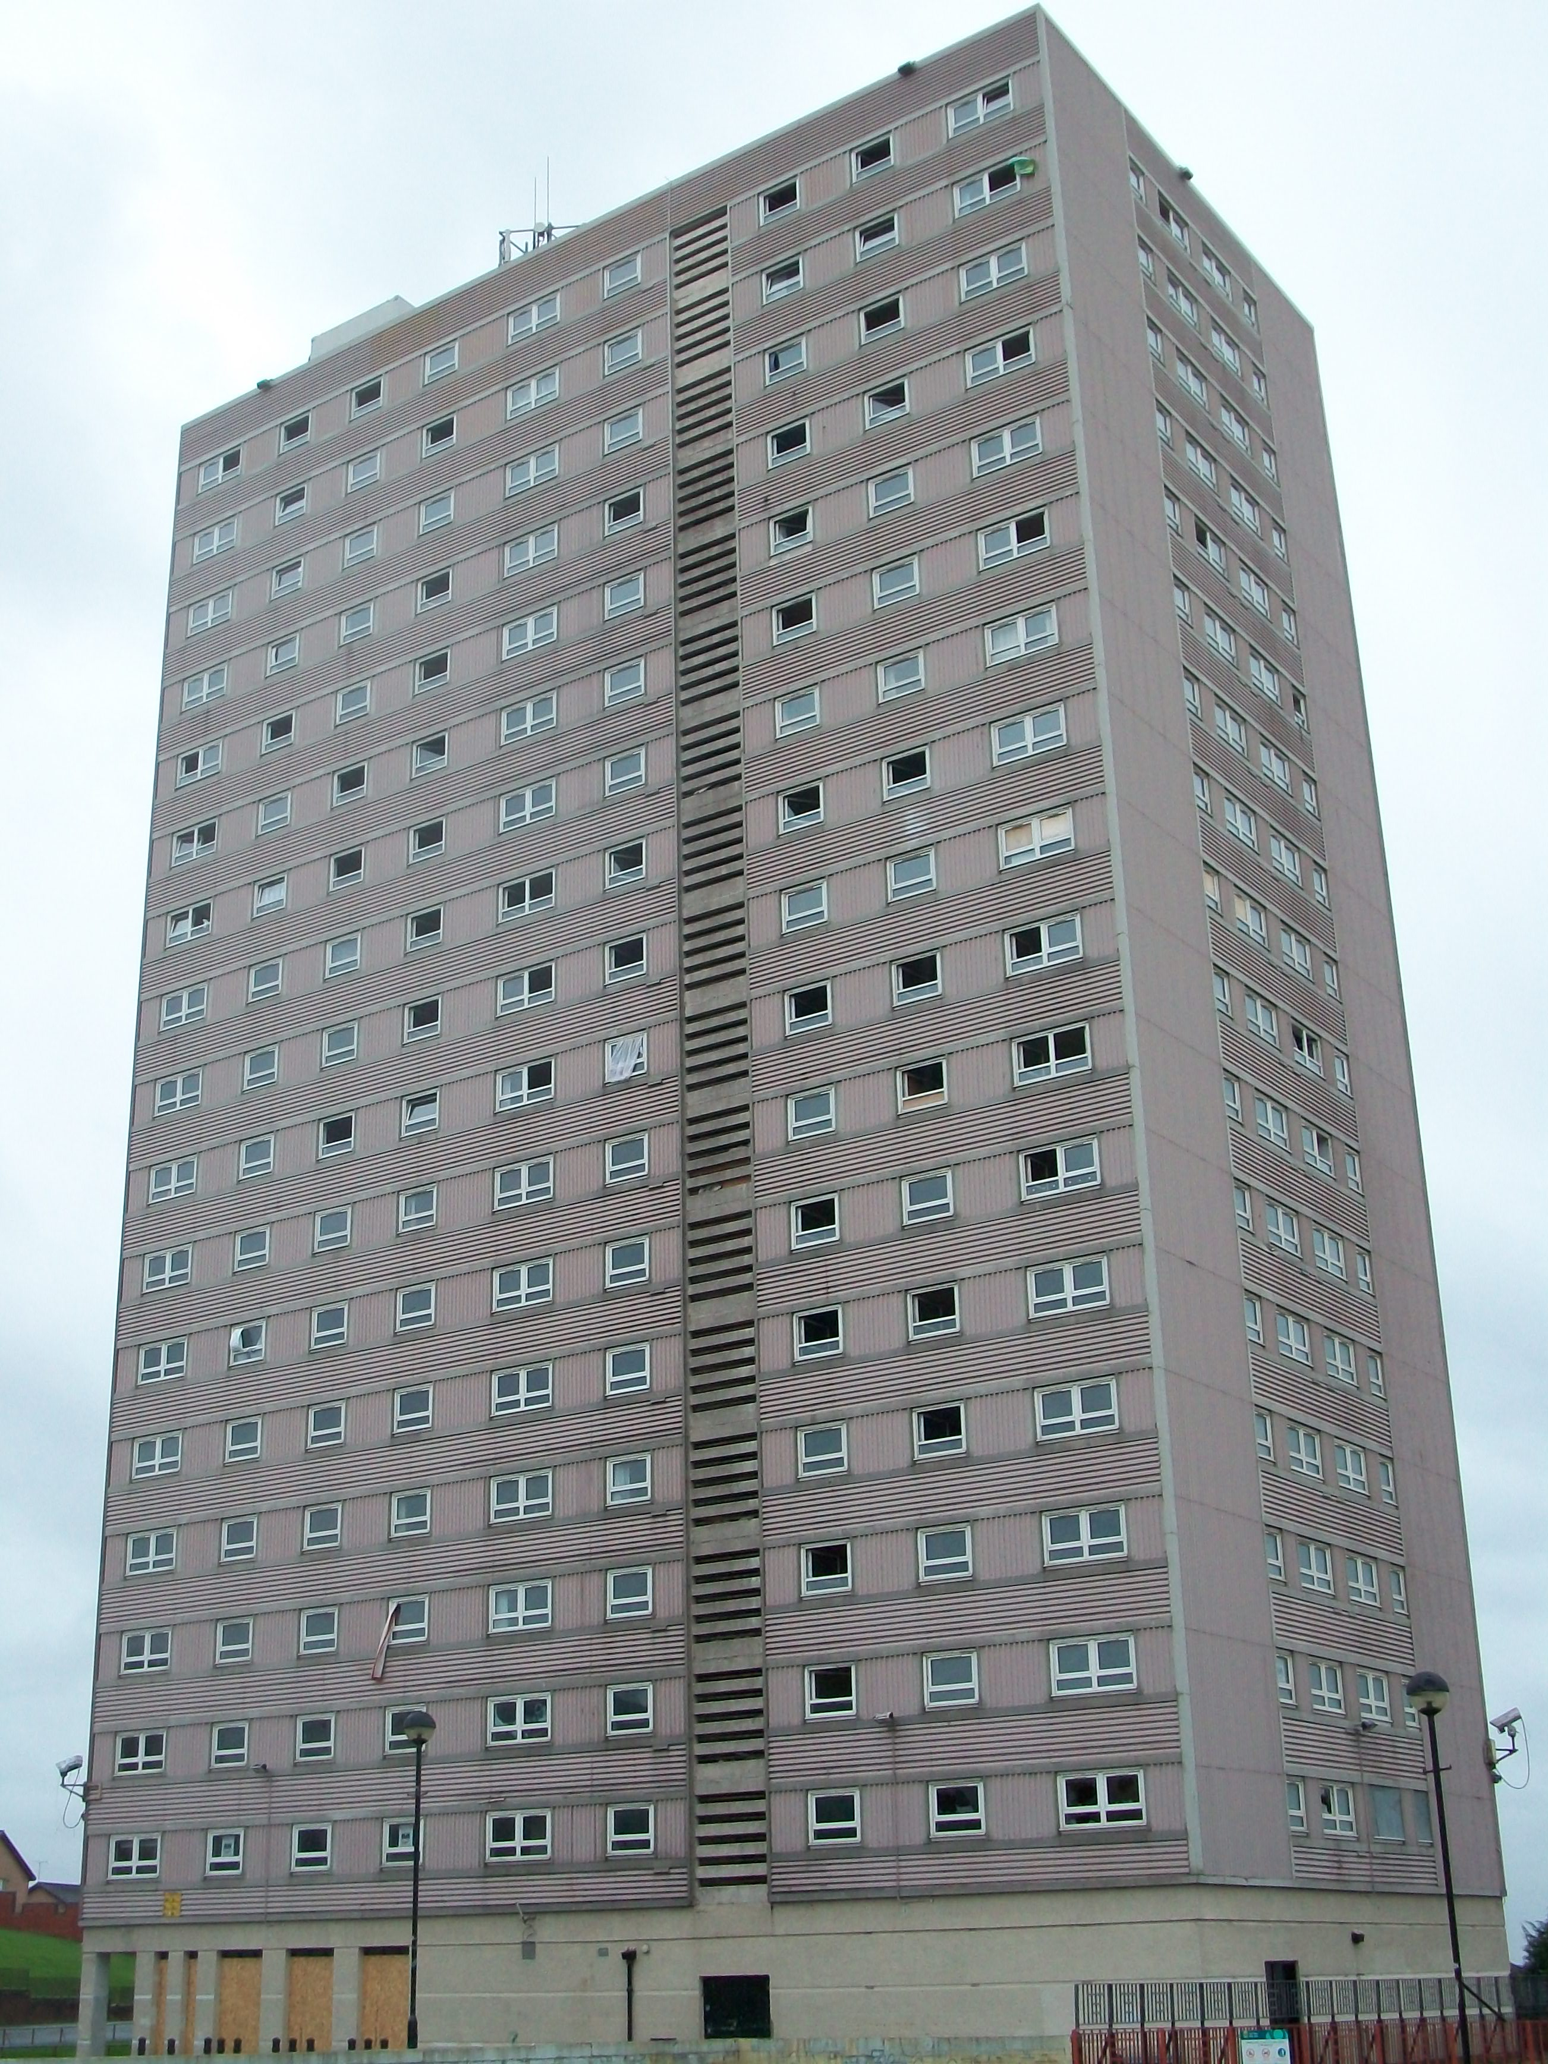
The building is due to be demolished by the controlled use of explosives on
Sunday 15th May 2011.
The demolition will be carried out under strictly controlled conditions with safety and technical personnel in attendance from Saturday 14th May Sunday 15th May.
Please be aware that there will be a great deal of dust being blown through the air from the collapsing building.
We strongly recommend that you avoid the area completely. We do not have a specific time for the blowdown but you will be able to view the demolition at www.collplacedemolition.co.uk

There will be some inconvenience to those who need to be evacuated, and to those who may be awakened by the demolition in the early hours of the morning. We apologise for this inconvenience and will do everything possible to minimise the disruption.

We hope you understand the need for certain measures to be taken to ensure the safe demolition of this building. We would like to take the opportunity to thank you for your assistance and look forward to your co-operation on Saturday 14th and Sunday 15th May 2011.
Check out the latest information at www.collplacedemolition.co.uk

SAFEDEM LTD Arthurstone House, Liff Road, Dundee, DD2 4TD
Tel: 0141 558 3433 Tel: 01382 811444 Fax: 01382 828244
www.safedem.co.uk email: info@safedem.co.uk
PLAN OF AREA

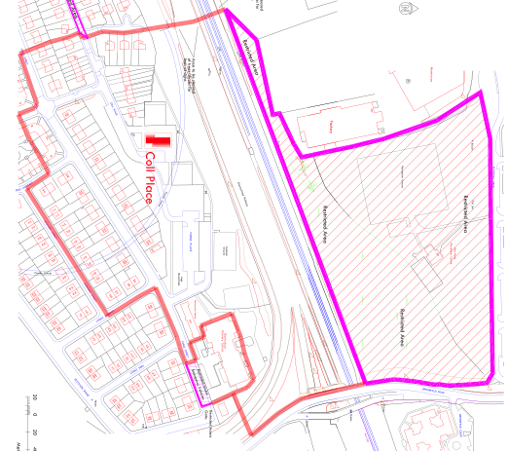

EXCLUSION ZONE INFORMATION
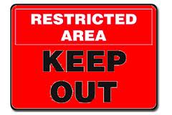
From 7:00pm on Saturday 14th May, the Exclusion Zone will be set up around the area. This is shown on the plan above. All properties within this Exclusion Zone must be evacuated. The residents and businesses that need to be evacuated have already been contacted and arrangements have been put in place for the evacuees.


There will be NO ENTRY into the Exclusion Zone area after 7:00pm except for authorised personnel. We expect the Exclusion Zone to be removed and re-entry into the area around 9:00am on Sunday 15th May.

INFORMATION


SECURITY OF THE AREA
During the operation, various security measures will be implemented in association with local police
to ensure premises are safe.


ROAD AND FOOTPATH CLOSURES
The following roads and footpaths within the exclusion zone will be closed from 7:00pm on Saturday 14th May and will re-open around 9:00 am on Sunday 15th May.

- Forge Place and Coll Place – both closed entirely
- Coll Street - from 102 Coll Street to Coll Place
- Forge Place - from 77 Forge Street to school janitor house
- Stroma Street - from 24 Stroma Street to Coll Street
- Stronsay Street – from 23 Stronsay Street to Forge Street
- Dinwiddie Street from Lockhart Street to Forge Street

PARKING RESTRICTIONS
No parking will be allowed within the exclusion zone boundary.
Parking restrictions will also be in place along many roads in the surrounding areas.
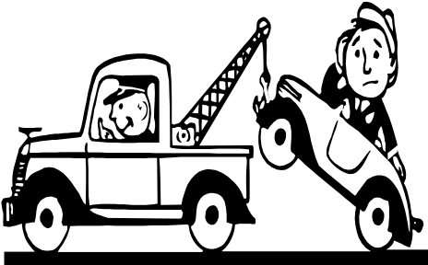
VEHICLE REMOVAL
Any vehicles left within the area causing an obstruction WILL BE removed. Any vehicles left on restricted or closed roads may also be uplifted. Please note a fee may be charged for this service. (Evacuees can remove their vehicles upon leaving the area).
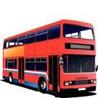
PUBLIC TRANSPORT
Any Public Transport affected by the operation will be re-routed.
Local Diversions will be in place



LOCAL SERVICES AND FACILITIES
Local church services should be unaffected by the operation. The football pitch, basketball court and Red Road Recreation Centre will be closed during the operation.

PRECAUTIONARY MEASURES


PROPERTY INSPECTIONS
Those properties closest to the multi storey building will be surveyed. Personnel will carry out external visual inspections of these properties using camera equipment in the run up to the demolition. Inspections will also take place immediately before and immediately after the demolition. These inspections are purely a precautionary measure and no damage is expected at any surrounding properties.


DUST
There is a possibility that dust may be blown through the air from the collapsing building towards your home or property. Although the dust is not harmful, we strongly recommend that you;
- Close all doors, windows and vents (re-open vents after the demolition)
- Do not hang out washing
- Cover garden/fish ponds/rabbit hutches
People with breathing difficulties should avoid the area on the day.

PETS
On the day of the demolition, we strongly recommend that
all pets be kept indoors ensuring that they cannot
escape through cat flaps or open windows or doors.

DELAYS
In the unlikely event of any delays, contingency plans have been made. This may result in an extended period of evacuation. Arrangements for evacuees are already in place, should an unexpected delay occur. If you have any concerns, please contact the telephone helpline number – 07540 823321


SITE SAFTEY
The works on site are ongoing and will continue for a number of months after the demolition takes place. Please remind all children, visitors etc. to stay away from the demolition site – it is very dangerous. There are also large-scale vehicles on site and travelling to and from the site. We ask you to take care crossing the roads in the area.


CONTACTS
Should you require further information or advice, please contact
TRACEY SINCLAIR or TAYLOR ELDER
on 0141 558 3433.

